Name
Course Title
Course Number
Semester

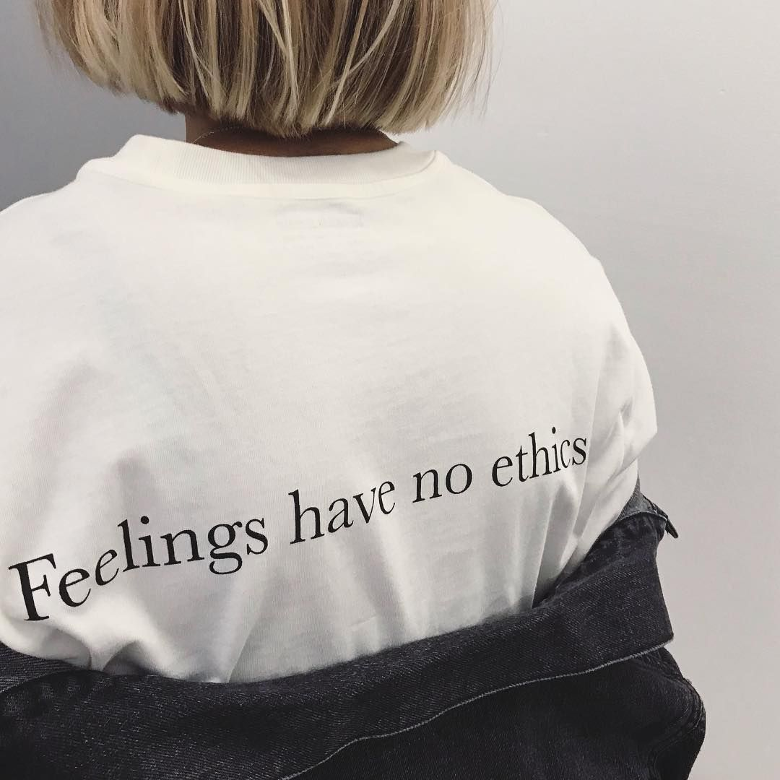

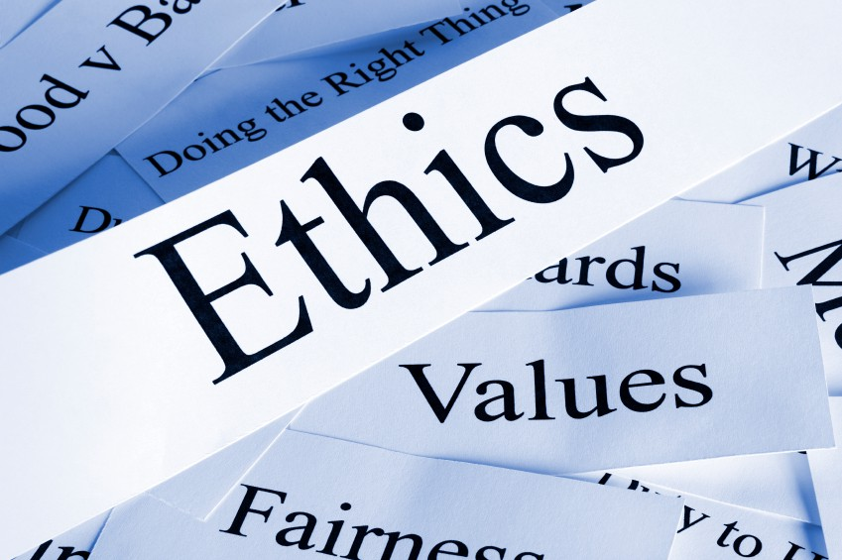\

Mission and Goals
Personal Mission Statement
To impact positively the life of every person I meet. I will act as an instrument of change in the workplace, in my family and the whole community at large. I will participate with gratitude, purpose and energy in all aspects of my life through the utilization of my God-given talent. Through this, I will provide a positive role model to all the people I interact with hence giving more than I take.
Professional Mission Statement
To serve as the most preferred change agent in my professional life by providing essential communication throughout the process. I will also make effective decisions that suit the majority of the employees and develop the right skills to communicate the benefits of change.
Life Balance Goals
Personal Goals | Professional Goals
I will maintain a lifestyle that is healthy by having personal exercises and every day cycling to work | I will challenge my family members, work colleagues, and my community to be aware that being fit is very key in living a healthy life
I will make the right decisions by consulting in order to attain results which are desired. | I will make sure before any change is implemented in the workforce; every voice of the employee is taken with concerns and listened.
I will make time for my family no matter how busy and engaged I am at the workplace. | I will assign each employee specific tasks concerning their skills.

Definitions
Ethics
This is the basic concepts and principles of conduct by human beings. Ethics entail what is morally right and wrong. Ethics entail the study of values, human rights, law of land obedience etc. Through ethics, there results in an understanding of individuals rights and responsibilities.
Leadership
This is the art of giving instructions to a group of people in attaining a common goal. It means giving directions to meet certain needs. Leadership is usually based upon ideas which are communicated. For leadership to be effective there is a requirement to have the right skills.
Service
This is the action of doing work for an individual or even helping. Services cannot be seen with a person own eyes. Services can only be felt when offered. A government offers services to its citizens such as transport, hospitals, energy supplies etc.
Character
It refers to a person behavior valued aspects. The traits of an individual are labelled with adjectives. A person character may be jealous, unfaithful, honesty etc. Character and personality are always taken to being similar although they are different.

Pressing Ethical Issue
In the workforce, diversity refers to an organization employing a workforce intentionally comprising the individuals of gender, race, sexual orientation, education among other attributes that are varying. “The result of diversity in the workforce is a plethora of benefits ranging from both internal and external perspectives.” (Konrad, Prasad & Pringle, 2006) However, despite implementing diversity in the workforce, there are some associated unique set of challenges. Therefore, the sections below review both sides of diversity in the workforce equation. Most organizations are as well as aiming at achieving workforce diversity.
Benefits of diversity in the workforce
A pool of talent which is wider
In the labor market today, most of the employees are no longer searching for a 9-to-5 job which is paying well but they are rather looking for an opportunity where they will grow, be challenged and feel accepted at the same time. A company embracing diversity in the workforce, therefore, attracts a wide range of candidates who are looking for the opportunity for their progress. This leads to more talents attracted to any diverse organization. Besides, an organization which aims at actively seeking diversity in candidate’s positions will have a pool of talent which is wider. Therefore, in aiming at finding good hires, organizations should embrace diversity in ethnicity, thought, and background among other factors. (In Aquino & In Robertson, 2018)
More innovation
More innovation is facilitated by workplace diversity. For instance, when an organization has a group of people which is homogenous then there are high chances that there is a sameness in the group including skills of solving problems. Creative solutions cannot be achieved by sameness in a group of employees. On the other hand, an organization comprising of a heterogeneous group of employees will contribute perspectives which are unique and lead to thoughtful breakthroughs. Recent studies have revealed that organizations which have demonstrated a lot of innovation tend to score well on diversity indicators. To put this in a more perspective, many organizations while holding important strategy meetings often tend to go offsite as fresh ideas are always sparked by an environment and circumstances which are new.
Performance of employee becomes better
Inclusion and diversity go hand-in-hand and whenever a work environment is created, employees feel comfortable being themselves as their cultures, backgrounds, and ways of thinking are represented well. This makes employees become more productive since they are happier. A natural cognitive diversity can be stifled by a homogeneous culture that is strong due to the pressure of conforming. Employees will more likely fear any form of rejection and fail to produce their best work in a situation where they are unable to be themselves whenever at work.
Increased Profits
Research and many studies have shown that there is a better performance by diverse organizations which results in increased profits. The financial performance, return on equity and financial returns improve due to diversity and therefore, diversity pays off.
New Perspectives
When an organization hires people from backgrounds, culture, and nationalities which are diverse, fresh arrays of perspectives are brought to the table. With this array of perspectives, problem-solving will become better and productivity will be increased.
Challenges of diversity in the workforce
Overcoming bias
Naturally, humans are biased and the vast majority of decisions by humans are not based on facts or logic but rather on intuition, beliefs, and biases. Despite an organization having the best intentions, diversified people will tend to bring bias in interactions of every day in the workforce. To solve this challenge, organizations will be required to invest in additional training to overcome bias.
Internal resistance
Diversity in the workforce unfortunately not everyone will be on board with the idea. Some people will oppose this idea actively in the workforce and the organization leader has to make an effort to educate employees constantly about the support of diversity efforts. Employees opposed to this idea should be made to understand the importance of diversity in the workforce. There should be clarity on this idea.
Training management
For diversity in the workforce to be successful it requires every stakeholder in the organization to cooperate since it does not happen in silos. These initiatives require huge influential from managers and investment in management training is very important so as to help in the diversity goals of an organization, their importance, and the expectations when interacting with employees. The solution for this challenge is for instance organizations outsourcing diversity training where customs solutions can be designed for the organization.
Diversity alignment with unique organizational goals
Diversity in the workforce implementation is a commitment which is very huge and cannot just be "borrowed" from another organization. Every organization has a set of goals which are unique and there should be alignment between diversity practices for there to be a success. The implication of this is that the organization-specific culture should be taken in to account when figuring the direction to go. The organization should not feel pressured and just copy and paste what other organizations around are implementing. The solution for this challenge is for an organization to consider using survey which is diversity-focused so that specific gaps can be identified and realize the resources which need to be focused. This will ensure no false assumptions are being made and time can be spent on the initiatives which will have a significant impact.
Moving from design to implementation
Without anybody implementing diversity programs even after design most thoughtful and detail-oriented one, then it serves no purpose. Therefore, an organization needs to have a team, support and resources in place to move the initiatives of diversity to implementation from design. For instance, an organization can have a Head of Diversity and Inclusion, a dedicated resource which is a solid way of ensuring an organization is being held accountable for results. “There should also be a consideration of a creative solution which will fit the organization structure.” (Konrad, Prasad & Pringle, 2006)

Case Study
Problem
Most of Apple goods are not manufactured domestically as most of the company sourcing of the component and production factory is done overseas. This has led to Apple critics argue that it is very dangerous to many works and very harmful to the environment. Apple products use the tin as a major component which is mostly sourced in Indonesia and some mines unethically source tin. In one study done, children work in conditions which are unsafe and dig tin by hands in mines which are landslides prone that could even bury them alive. About 70% of the tin Apple uses come from these prone areas as a BBC investigation revealed where a 12-year-old was working at the bottom of a cliff which was 70-foot and the young one claimed to worry a lot about landslides. In this case, criticism is not the problem but rather the working conditions of tin miners who include children.
Input
Many people, as well as the Apple Company, know this issue that most of their sourced tin is dug out by hand in landslides prone Indonesia and workers including children work in conditions which are not safe. Apple rather than aiming at solving the problem makes a coward move to defend itself by claiming the sourcing practices are a very complex process. For a company selling 74.5 million iPhones in 2014 and being in the line to make over $52 billion in 2015 is extremely wrong and a big failure. Apple defending itself and saying it can unilaterally refuse tin from BBC reveals how the company is unbothered and only aiming at making big cash. It is only looking at a way to shield itself from critics and not realizing that tin even in other countries is mined in challenging conditions. People working to mine tin in areas prone to landslides have made the company successful despite Apple failing to recognize this.
Solution
Apple rather than shielding itself from criticism and unilaterally refusing tin from Indonesia it should look for ways which will improve the working conditions of the workers and come up with measures to ensure children rights are protected. Also, Apple should adopt strategies for ensuring environment conservation following the mining of tin in areas such as cliffs. This way, the company will have done what can be said to giving back to the Indonesian community which has been part of Apple succeeds despite the company acting blind. Apple SWOT analysis is presented in the below table.
SWOT Analysis
Strengths | Weaknesses | Opportunities | Threats
High profits | Running away from critics | Growing iPhones demand | Supplier bad working conditions
 | Failing to improve tin suppliers working conditions |  | Critics

Choice
Apple has to improve the working conditions of tin suppliers and control children involvement in tin digging. To do this, the company can set schools where the likes of 12-year-old miners could go to school and promise them jobs in this company which will make them work hard to achieve their goals. For adults who work in landslide-prone areas, the company can partner with the Indonesian government to ensure they protect the environment by filling the cliffs and mines with sand. Apple ca as well as set plants in Indonesia to appreciate its success story to the people of Indonesia.
Operation
For Apple to improve working conditions of the tin suppliers, it should set its goal right. This goal should go hand in hand with Apple policies as far as suppliers working conditions are concerned. Apple will be entirely responsible for this but it has to seek the government of Indonesia intervention so that there is a smooth transition.
Course Summary
This course was helpful to me and offered an opportunity of placing myself as a leader and be able to solve ethical decisions. I have learned the criteria that I can use to define an ethical leader who is aware of the values of an organization as well as his/her values and who can set the organization tone. The course has widened my understanding of ethical dilemma which faces many leaders. Ethics, as I have learned from the course, is part of every leader and plays a major role in determining the success of an organization. I am thankful for the instructor and materials learned in this course as I have even been able to develop my personal and professional mission statement which to be honest I did not have. This course has made a huge difference in my thinking regarding ethics as I thought ethics is necessary while practising my profession which is not the case. I enjoyed this course a lot. (Wagner & Simpson, 2009)

References
Wagner, P. A., & Simpson, D. J. (2009). Ethical decision making in school administration: Leadership as moral architecture. Los Angeles, [Calif.: SAGE.
Maxcy, S. J. (2002). Ethical school leadership. Lanham, Md: Scarecrow Press.
Konrad, A. M., Prasad, P., & Pringle, J. K. (2006). The handbook of workplace diversity. London: Sage Publications.
In Aquino, C. T. E., & In Robertson, R. (2018). Diversity and inclusion in the global workplace: Aligning initiatives with strategic business goals.

